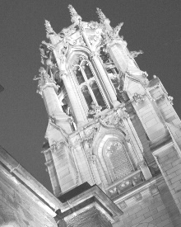
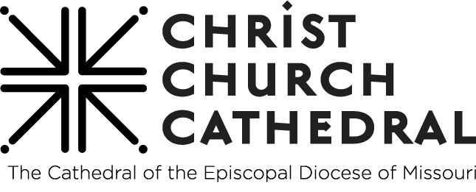

The Sixth Sunday of Easter, Year A
Blessed Mothering Day

May 10, 2026, 10:30 a.m.
Be Here, Be You, Be Loved

Welcome to Christ Church Cathedral!
The People’s responses are in bold print.

We have large print bulletins and hearing devices available. If you need them, ask an usher.

Land Acknowledgment for the Diocese of Missouri (updated 7/2022)
In humility, we recognize and acknowledge that we in the Diocese of Missouri worship and live on the traditional ancestral lands of the Osage Nation, the Illiniwek/Peoria Tribe, the O-Gah-Pah (Quapaw) Tribe, the Otoe-Missouria Tribe, and other First Peoples. We recognize our mutual dependence upon and benefit from this land; we proclaim our solidarity with and our debt to the Peoples who first claimed and improved this land as their home. We acknowledge our complicity in the process of colonization that dispossessed the First Peoples from their ancestral lands. We affirm our commitment to stand with indigenous communities today and henceforth as they seek justice and resist continued threats to their sovereignty and humanity.

We are also cognizant that the history of The Episcopal Church is intertwined with the history of colonialism and slavery in the United States. More than four centuries ago, the first enslaved Africans were brought to the Americas, and two centuries ago enslaved and indigenous persons contributed to the exploration of this state by Lewis and Clark. Our state’s history is entangled with both the Missouri Compromise making this state officially a slave state, and the case of Scott v. Emerson that petitioned for Dred and Harriet Scott’s emancipation. We acknowledge the tragic legacy of slavery in our diocese, and the blood, sweat, and tears of enslaved people that soak the earth beneath our feet in Missouri. This legacy persists today as we continue to work towards racial justice, equity, liberation, and community, here in Missouri and across The Episcopal Church.

PRELUDE St. Columba Healy Willan

OPENING SONG Thine is the Glory, Judas Maccabeus George Frideric Handel
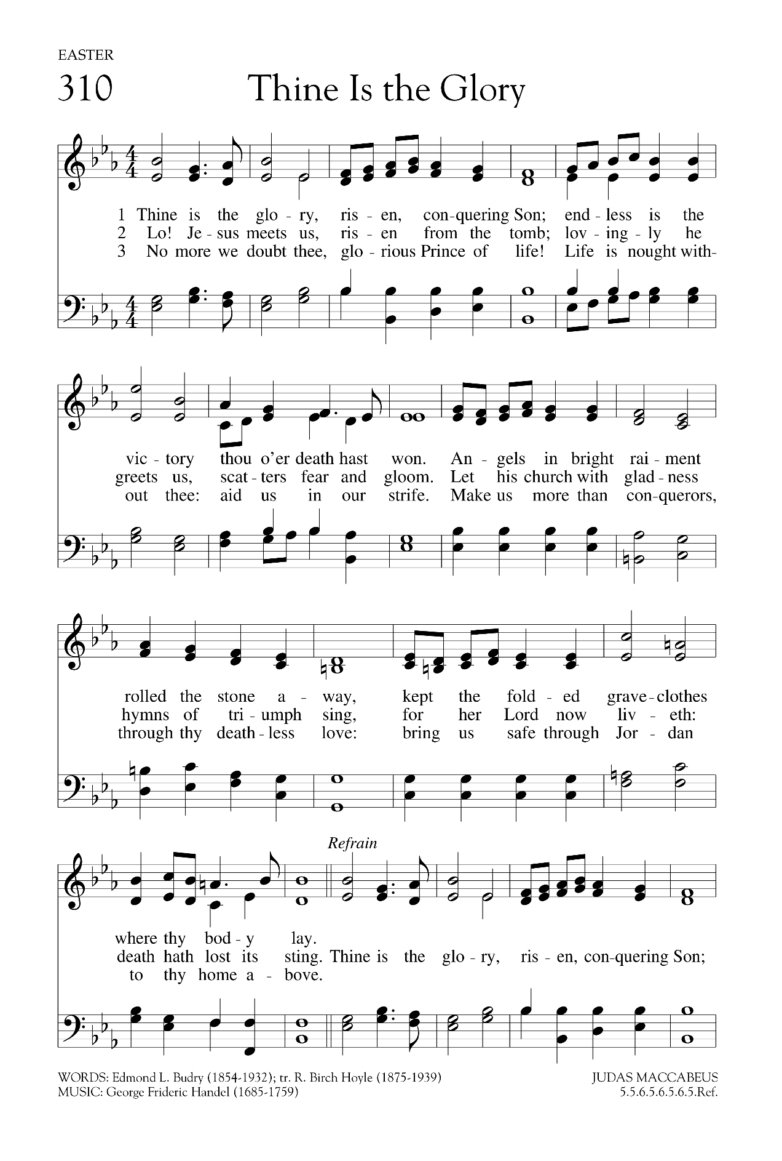


WELCOME!

THE GATHERING OF GOD'S PEOPLE
Presider Let us gather ourselves into Christ’s presence with a moment of silence.
Moment of silence to open our hearts.

EASTER GREETING
Presider Alleluia. Christ is risen.
People The Lord is risen indeed. Alleluia.

THE COLLECT FOR PURITY
Presider Almighty God, to you all hearts are open, all desires known, and from you no secrets are hid: Cleanse the thoughts of our hearts by the inspiration of your Holy Spirit, that we may perfectly love you, and worthily magnify your holy Name; through Christ our Savior. Amen.

THE SONG OF PRAISE: S-280 (revised) Gloria Powell

THE COLLECT OF THE DAY
Presider God is with you.
People And also with you.
Presider Let us pray. Three-fold God of love, you invite us to abide in you. May we follow the Spirit of truth, so that through us your commanding love may speak to the heart of the world; through Jesus Christ our Lord. Amen. Prayers for an Inclusive Church (2009) alt.; from Alternative Collects for Years A, B & C of the Revised Common Lectionary 2022, Anglican Church of Canada

WE HEAR THE SACRED STORIES

THE FIRST READING Please be seated. Acts 17:22-31
Paul stood in front of the Areopagus and said, “Athenians, I see how extremely religious you are in every way. For as I went through the city and looked carefully at the objects of your worship, I found among them an altar with the inscription, ‘To an unknown god.’ What therefore you worship as unknown, this I proclaim to you. The God who made the world and everything in it, he who is Lord of heaven and earth, does not live in shrines made by human hands, nor is he served by human hands, as though he needed anything, since he himself gives to all mortals life and breath and all things. From one ancestor he made all nations to inhabit the whole earth, and he allotted the times of their existence and the boundaries of the places where they would live, so that they would search for God and perhaps grope for him and find him — though indeed he is not far from each one of us. For ‘In him we live and move and have our being’; as even some of your own poets have said, ‘For we too are his offspring.’ Since we are God’s offspring, we ought not to think that the deity is like gold, or silver, or stone, an image formed by the art and imagination of mortals. While God has overlooked the times of human ignorance, now he commands all people everywhere to repent, because he has fixed a day on which he will have the world judged in righteousness by a man whom he has appointed, and of this he has given assurance to all by raising him from the dead.”
Reader Hear what the Holy Spirit is saying to God’s People.

People Thanks be to God.

PSALM 66:7-18 (General Synod 2016 Liturgical Psalter, Anglican Church of Canada, pointed by Connor Scott)

The Antiphon is sung by all before and after the psalm.
The Choir will sing the verses, and all are welcome to sing along.
Antiphon

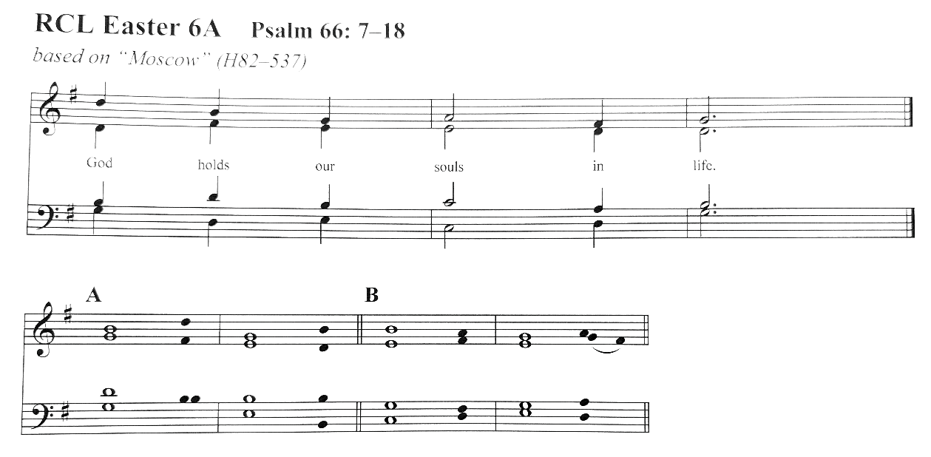
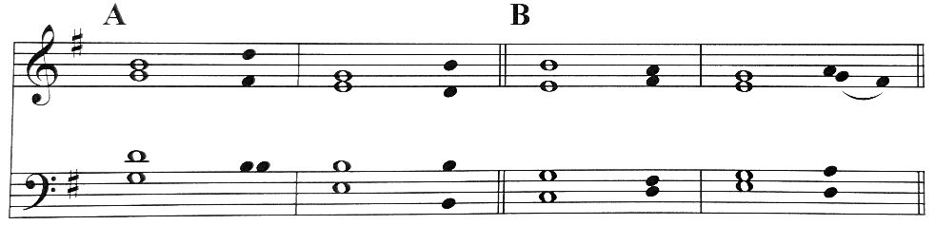

Antiphon
7 Bless our God, you • peoples; *
make the voice of God’s praise to be • heard;
8 who holds our • souls in life, *
and will not allow our • feet to slip.
9 For you, O God, have • proved us; *
you have tried us just as • silver is tried.
10 You brought us into the • snare; *
you laid heavy burdens upon our • backs.
11 You let enemies ride over our heads; we went through fire and • water; *
but you brought us out into a • place of refreshment.
12 I will enter your house with burnt-offerings and will • pay you my vows, *
which I promised with my lips and spoke with my mouth when • I was in trouble.
13 I will offer you sacrifices of fat beasts with the • smoke of rams; *
I will give you • oxen and goats.
14 Come and listen, all you who • fear God, *
and I will tell you what the • Lord has done for me,
15 The One to whom I called out • with my mouth *
and whose praise was • on my tongue.
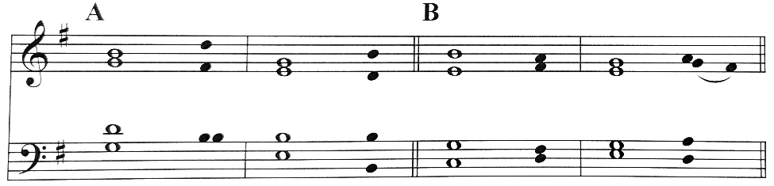

16 If I had found • evil in my heart, *
the Lord would not have • heard me;
17 But in truth • God has heard me *
and has attended to the • voice of my prayer.
18 Blessed be God, who has • not rejected my prayer, *
nor withheld steadfast • love from me.
Antiphon
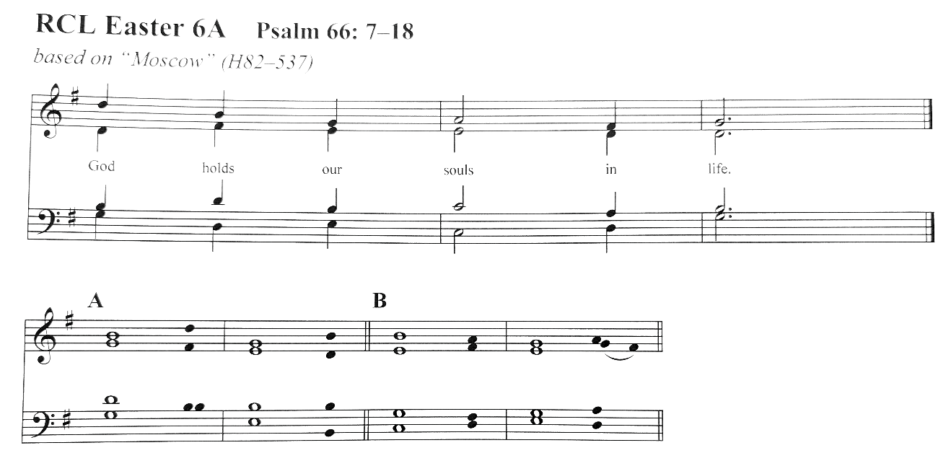

THE SECOND READING 1 Peter 3:13-22
Now who will harm you if you are eager to do what is good? But even if you do suffer for doing what is right, you are blessed. Do not fear what they fear, and do not be intimidated, but in your hearts sanctify Christ as Lord. Always be ready to make your defense to anyone who demands from you an accounting for the hope that is in you; yet do it with gentleness and reverence. Keep your conscience clear, so that, when you are maligned, those who abuse you for your good conduct in Christ may be put to shame. For it is better to suffer for doing good, if suffering should be God’s will, than to suffer for doing evil. For Christ also suffered for sins once for all, the righteous for the unrighteous, in order to bring you to God. He was put to death in the flesh, but made alive in the spirit, in which also he went and made a proclamation to the spirits in prison, who in former times did not obey, when God waited patiently in the days of Noah, during the building of the ark, in which a few, that is, eight persons, were saved through water. And baptism, which this prefigured, now saves you — not as a removal of dirt from the body, but as an appeal to God for a good conscience, through the resurrection of Jesus Christ, who has gone into heaven and is at the right hand of God, with angels, authorities, and powers made subject to him.
Reader Hear what the Holy Spirit is saying to the Church.

People Thanks be to God.

SEQUENCE HYMN 204 NOËL NOUVELET
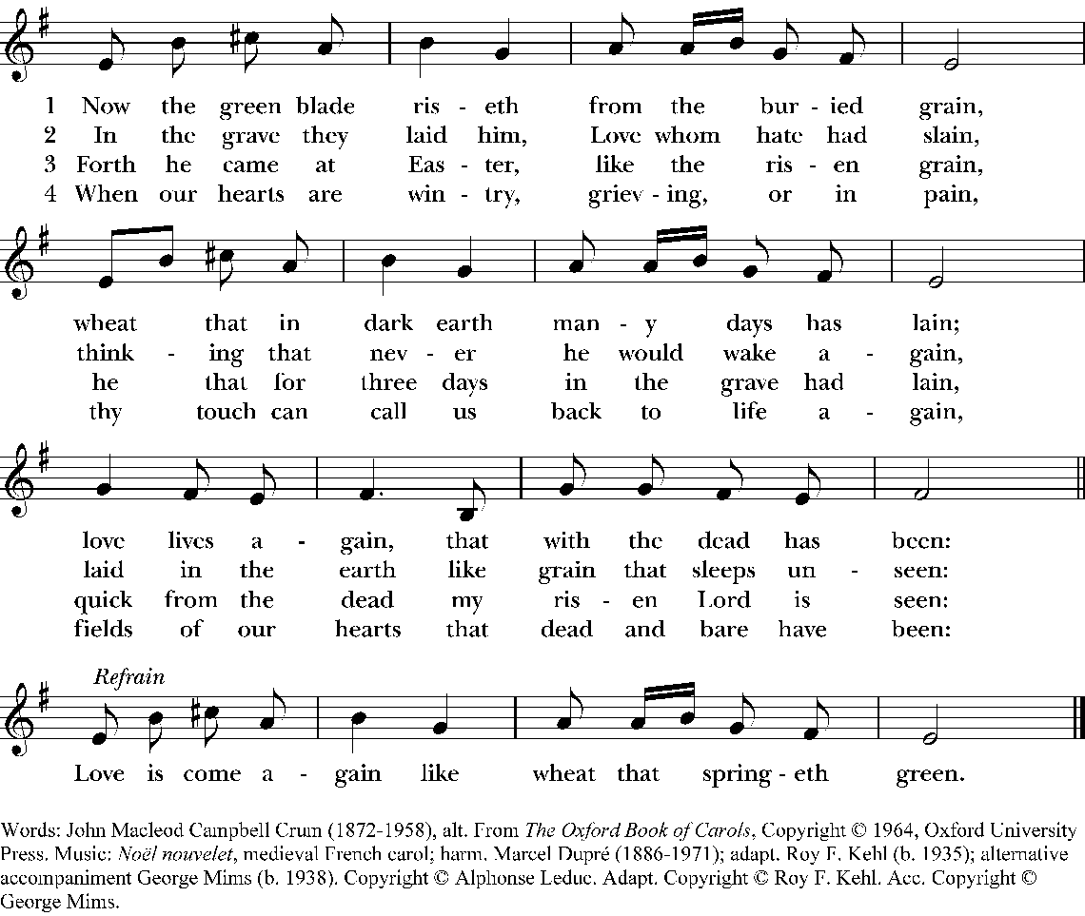

THE GOSPEL John 14:15-21
Deacon The Holy Gospel of our Savior Jesus Christ according to John.
People Glory to you, O Christ.
“If you love me, you will keep my commandments. And I will ask the Father, and he will give you another Advocate, to be with you forever. This is the Spirit of truth, whom the world cannot receive, because it neither sees him nor knows him. You know him, because he abides with you, and he will be in you. I will not leave you orphaned; I am coming to you. In a little while the world will no longer see me, but you will see me; because I live, you also will live. On that day you will know that I am in my Father, and you in me, and I in you. They who have my commandments and keep them are those who love me; and those who love me will be loved by my Father, and I will love them and reveal myself to them.”
Deacon The Gospel of our Savior.
People Praise to you, O Christ.
Please be seated.

THE SERMON The Very Rev. Kathie Adams-Shepherd
Moment for silent reflection

THE AFFIRMATION OF FAITH: THE NICENE CREED (Expansive Liturgies, ECUSA) Please stand as you are able.
All We believe in one God, the Father, the Almighty, maker of heaven and earth, of all that is, seen and unseen. We believe in one Lord, Jesus Christ, the only Son of God, eternally begotten of the Father, God from God, Light from Light, true God from true God, begotten, not made, of one Being with the Father; through him all things were made.
For us and for our salvation he came down from heaven:
was incarnate of the Holy Spirit and the Virgin Mary and became truly human.
For our sake he was crucified under Pontius Pilate; he suffered death and was buried.
On the third day he rose again in accordance with the Scriptures;
he ascended into heaven and is seated at the right hand of the Father.
He will come again in glory to judge the living and the dead, and his kingdom will have no end.
We believe in the Holy Spirit, the Lord, the giver of life, who proceeds from the Father,
who with the Father and the Son is worshiped and glorified,
who has spoken through the prophets.
We believe in one holy catholic and apostolic Church.
We acknowledge one baptism for the forgiveness of sins.
We look for the resurrection of the dead, and the life of the world to come. Amen.

THE PRAYERS OF THE PEOPLE (Dr. Gail Ramshaw, adapted)
Deacon Let us name before God those for whom we offer our prayers.
The people audibly or silently name those for whom they are interceding.

Leader Our gracious God calls us to be ministers of reconciliation in a world refusing honor to God. In acknowledgement of our Lord’s command, let us place our prayers before God saying: O God, hear our prayer

Leader For the courage to live out God’s commandments, graciously and without reservation, let us pray.
People O God, hear our prayer.

Leader For zealous preachers of the word, that by the Holy Spirit, they open the ears of their hearers to the good news of salvation and their eyes to the loveliness of God’s wisdom. We pray for Sarah, Archbishop of Canterbury, Sean, Presiding Bishop; Deon, our bishop; Kathie, our dean; and the staff and Chapter of our Cathedral. In our Diocese of Missouri, we pray for the people and ministry of St. Vincent's-in-the-Vineyard Episcopal Church in Ste. Genevieve and Marshall & Pamela, their priests. In our companion Diocese of Puerto Rico, we pray for St. Matthew the Apostle Mission in Penuelas. In the Anglican Communion, we pray for The Church of Pakistan (United). In the Armed Forces and Federal Ministries, we pray for our chaplains, military members, their families, and for those serving in North Dakota. For the people of the diocese and our cathedral congregation as we live into God’s vision and call among us, let us pray.
People O God, hear our prayer.

Leader For those chosen to govern peoples and nations, that God may grant them wisdom to promote the welfare of their people and the courage to work towards true peace, let us pray.
People O God, hear our prayer.

Leader For those who suffer from any form of oppression, that their tormentors learn to fear God’s will and follow God’s love, let us pray.
People O God, hear our prayer.

Leader For all who are sick, in need of our prayers and your healing presence, including the people of the Middle East, Cuba, Ukraine, Russia, Haiti, Sudan, and Libya; our tornado affected neighbors, immigrant and trans siblings; the Gerhart, Coffey and Hall families, Rosie, Tom, Linda, Lauren, Huldah, Dannie, Marjie, George, Rick & Kurt, Canon Desirée, Laura, Marjorie, Adele, Thelma & Raymond, Kathy, Michael, Warren; all in prison and their families; and those affected by violence and oppression in all forms, that they would be comforted in their distress, let us pray.
People O God, hear our prayer.

Leader For all the mothers among us today: our own mothers, those living and those who have died; those mothers who have loved us and those who have fallen short of loving us fully. For those who hope to be mothers someday, and those whose hopes to have children have been frustrated; and those mothers who have lost children and those have been as mothers to us. Let us pray.
People O God, hear our prayer.

Leader For our own needs, that we may rejoice in Christ’s command to celebrate his redeeming death and resurrection, and so live out the mystery of the cross in our daily lives, let us pray.
People O God, hear our prayer.

Leader For those who have died, including at the hand or in the custody of DHS, all slain in Sudan, the Middle East, and Ukraine; for Gerry Gerhart, Katy Coffey, Lowell D. Hall, Jr., those 32 lives taken by gun violence in the city of St. Louis in 2026 represented in the light of the small candles on the high altar, and all who die at the hand of another, or by their own hand. That they may receive eternal rest, let us pray.
People O God, hear our prayer.

All Loving God, in your unsearchable wisdom you command us to do what is right and good, so that through faith-filled action we may come to recognize your loving concern for us. May we always be single-minded in carrying out your commands, especially to be reconciled with one another, and to approach your holy table in peace and unity. We make this prayer through Christ our Savior. Amen.

THE EXCHANGE OF THE PEACE Please stand as you are able.
Presider The peace of Christ be always with you.
People And also with you.
The people greet each other with a sign of peace.

Please be seated.
ANNOUNCEMENTS

GATHERING AT CHRIST’S TABLE

OFFERTORY ANTHEM You Cannot Lose My Love Sarah Groves, arr. Susan Labarr
You will lose your baby teeth. At times, you'll lose your faith in me. You will lose a lot of things, But you cannot lose my love.
You may lose your appetite, Your guiding sense of wrong and right. You may lose your will to fight, But you cannot lose my love.
You will lose your confidence. In times of trial, your common sense. You may lose your innocence, But you cannot lose my love.
Many things can be misplaced; Your very memories be erased. No matter what the time or space, You cannot lose my love.
You cannot lose, You cannot lose, You cannot lose my love.

THE DOXOLOGY J. Mary Luti

THE EUCHARISTIC PRAYER: The Great Thanksgiving Enriching Our Worship 3
Presider God is with you.
People And also with you.
Presider Lift up your hearts.
People We lift them to the Lord.
Presider Let us give thanks to the Lord our God.
People It is right to give our thanks and praise.
Presider All thanks and praise are yours at all times and in all places, our true and loving God; through Jesus Christ, your eternal Word, the Wisdom from on high by whom you created all things. You laid the foundations of the world and enclosed the sea when it burst out from the womb; You brought forth all creatures of the earth and gave breath to humankind. Wondrous are you, Holy One of Blessing, all you create is a sign of hope for our journey; and so, as the morning stars sing your praises, we join the heavenly beings and all creation as we shout with joy:

SANCTUS S-125 Please kneel or stand as you are able. Proulx

Please stand or kneel as you are able.

Presider Glory and honor are yours, Creator of all, your Word has never been silent; you called a people to yourself, as a light to the nations, you delivered them from bondage and led them to a land of promise. Of your grace, you gave Jesus to be human, to share our life, to proclaim the coming of your holy reign and give himself for us, a fragrant offering. Through Jesus Christ our Redeemer, you have freed us from sin, brought us into your life, reconciled us to you, and restored us to the glory you intend for us.

We thank you that on the night before he died for us Jesus took bread, and when he had given thanks to you, he broke it, gave it to his friends and said: “Take, eat, this is my Body, broken for you. Do this for the remembrance of me.”

After supper Jesus took the cup of wine, said the blessing, gave it to his friends and said: “Drink this, all of you: this cup is the new Covenant in my Blood, poured out for you and for all for the forgiveness of sin. Do this for the remembrance of me.”

And so, remembering all that was done for us: the cross, the tomb, the resurrection and ascension, longing for Christ’s coming in glory, and presenting to you these gifts your earth has formed and human hands have made, we acclaim you, O Christ:

All Dying, you destroyed our death. Rising, you restored our life. Christ Jesus, come in glory!

Presider Send your Holy Spirit upon us and upon these gifts of bread and wine that they may be to us the Body and Blood of your Christ. Grant that we, burning with your Spirit’s power, may be a people of hope, justice, and love. Giver of Life, draw us together in the Body of Christ, and in the fullness of time gather us with all your people into the joy of our true eternal home.

Through Christ and with Christ and in Christ, by the inspiration of your Holy Spirit, we worship you our God and Creator in voices of unending praise.

All Blessed are you now and for ever. AMEN.

THE LORD’S PRAYER
Presider And now, as our Savior Christ has taught us, we are bold to pray,
All Our Father, who art in heaven, hallowed be thy Name, thy kingdom come, thy will be done, on earth as it is in heaven. Give us this day our daily bread. And forgive us our trespasses, as we forgive those who trespass against us. And lead us not into temptation, but deliver us from evil.
For thine is the kingdom, and the power, and the glory, for ever and ever. Amen.

THE BREAKING OF THE BREAD
The bread is broken. Silence is kept.

Presider Alleluia, Alleluia. God of promise, you have prepared a banquet for us.
People Happy are those who are called to the supper of the Lamb. Alleluia, Alleluia!
Presider Behold what you are.
People May we become what we receive.

THE INVITATION
Presider These are God’s holy gifts, for you, God’s holy people.
The Presider may add:
So come to this table you who have much faith or you who would like to have more; you who have been here often and you who have not been here in a long time. Come. It is Christ who invites us to meet him here.

SHARING THE SACRED MEAL
This is Christ’s table and all are welcome to be fed. Please follow the movement to the altar; communion will be distributed at the head of the center aisle. Remember to take your purse/personal belongings with you when leaving your seat for communion.

Those participating at home may, if they wish, say this prayer during the time of Communion:
Lord of the Feast, we thank you for gathering us as your people. We call to remembrance the many times we have been fed at your table and we lament our distance now. Be present Lord Jesus as you were present with your disciples, be known to us in the breaking of the bread, and may your Holy Spirit sustain us and all your Church until we can gather together again. We ask this for the sake of your love. Amen.

COMMUNION ANTHEM If Ye Love Me - John 14:15–17 Thomas Tallis (1505–1585)
If ye love me, keep my commandments. And I will pray the Father, and he shall give you another comforter,
that he may 'bide with you forever; E'en the sp'rit of truth.

COMMUNION HYMN LEVAS II 133 Winfield S Weeden
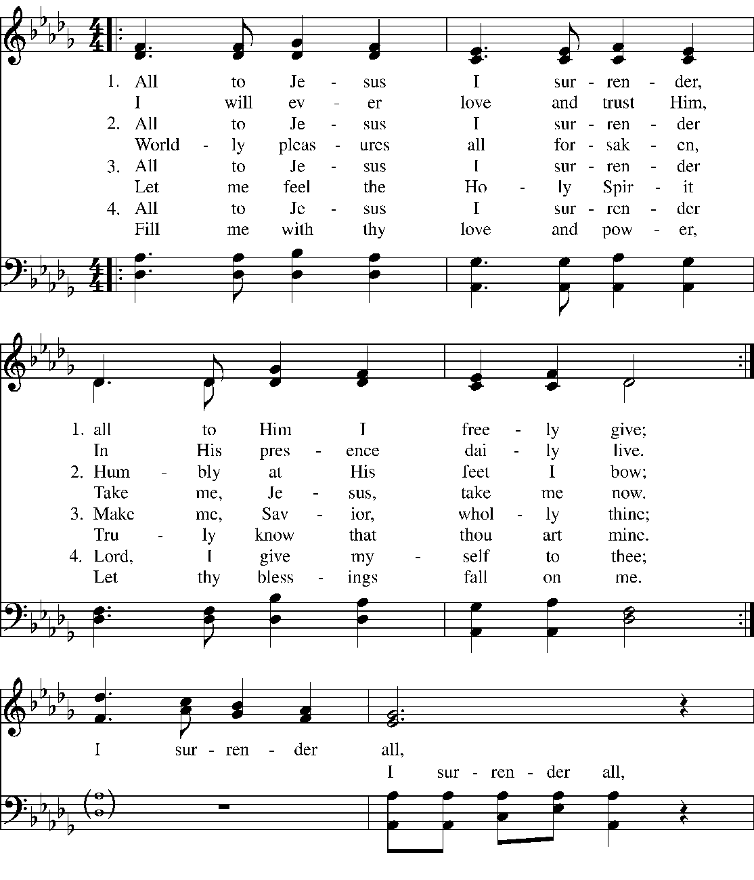
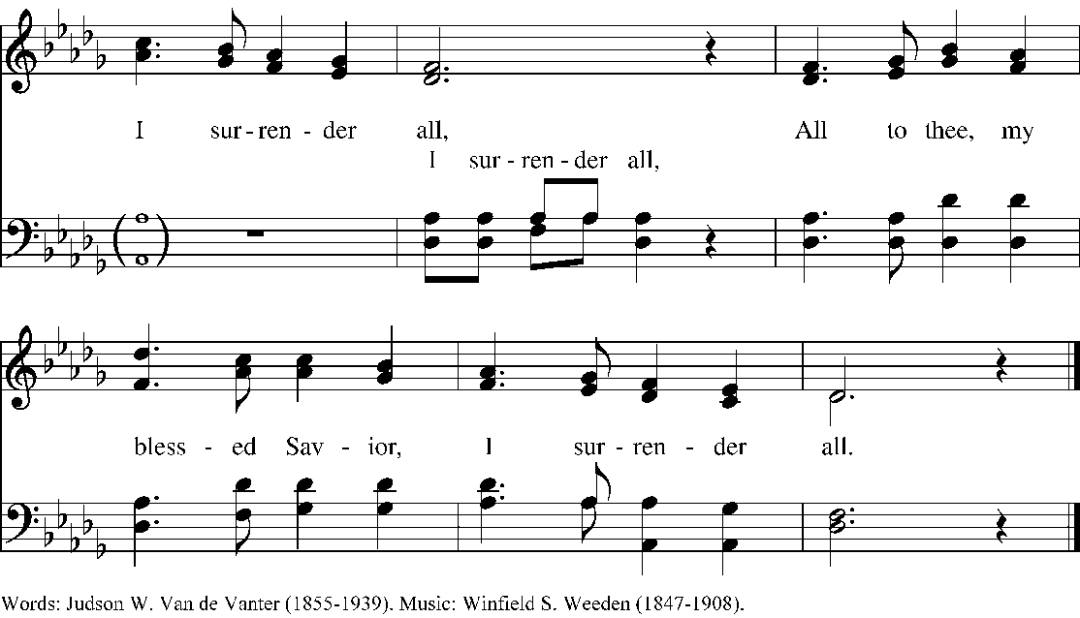

SENDING OF EUCHARISTIC VISITOR(S)
Deacon In the name of this congregation, we send you forth bearing these holy gifts, that those to whom you go may share with us in the communion of Christ’s Body and Blood.
People We who are many are one body, for we all share in the one bread, one cup.

THE POSTCOMMUNION PRAYER (Book of Common Prayer) Please stand as you are able
Presider God is with you.
People And also with you.
Presider Let us pray.
All Loving God, we give you thanks for restoring us in your image and nourishing us with spiritual food in the Sacrament of Christ’s Body and Blood. Now send us forth a people, forgiven, healed, renewed; that we may proclaim your love to the world and continue in the risen life of Christ our Savior. Amen.

EASTER BLESSING (Book of Occasional Services)

Presider The God of peace, who brought again from the dead our Savior Jesus Christ, the great Shepherd of the sheep, through the blood of the everlasting covenant, make you perfect in every good work to do God’s will, working in you that which is well-pleasing in God’s sight; and the blessing of God Almighty, Creator, Redeemer, and Sanctifier, be among you, and remain with you always. Amen.

CLOSING SONG 460 HYFRYDOL
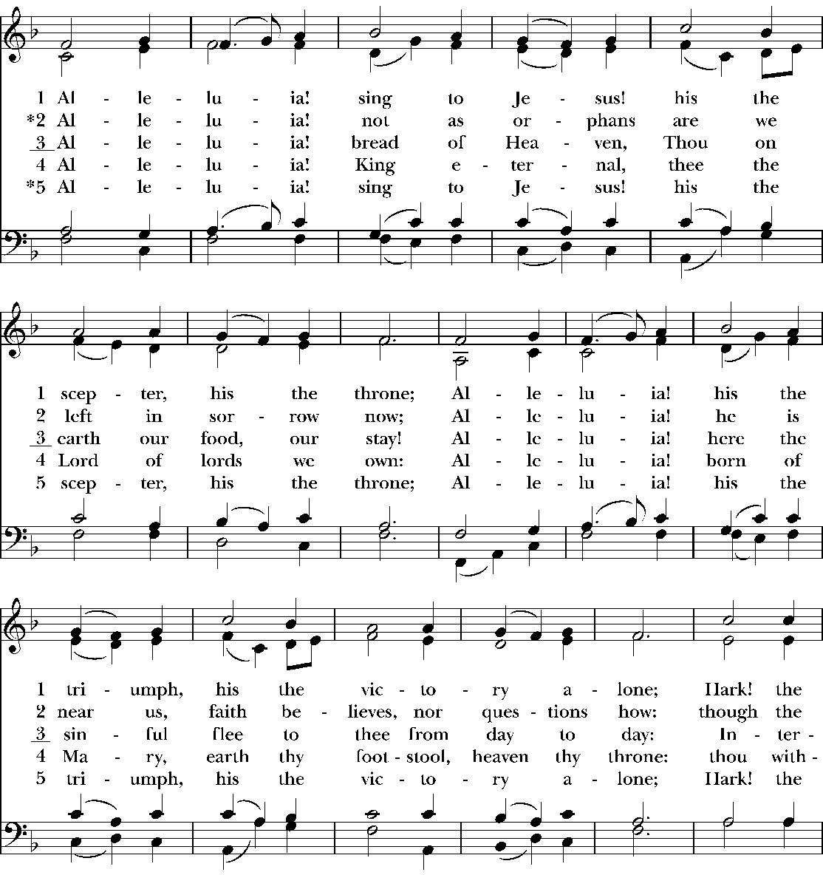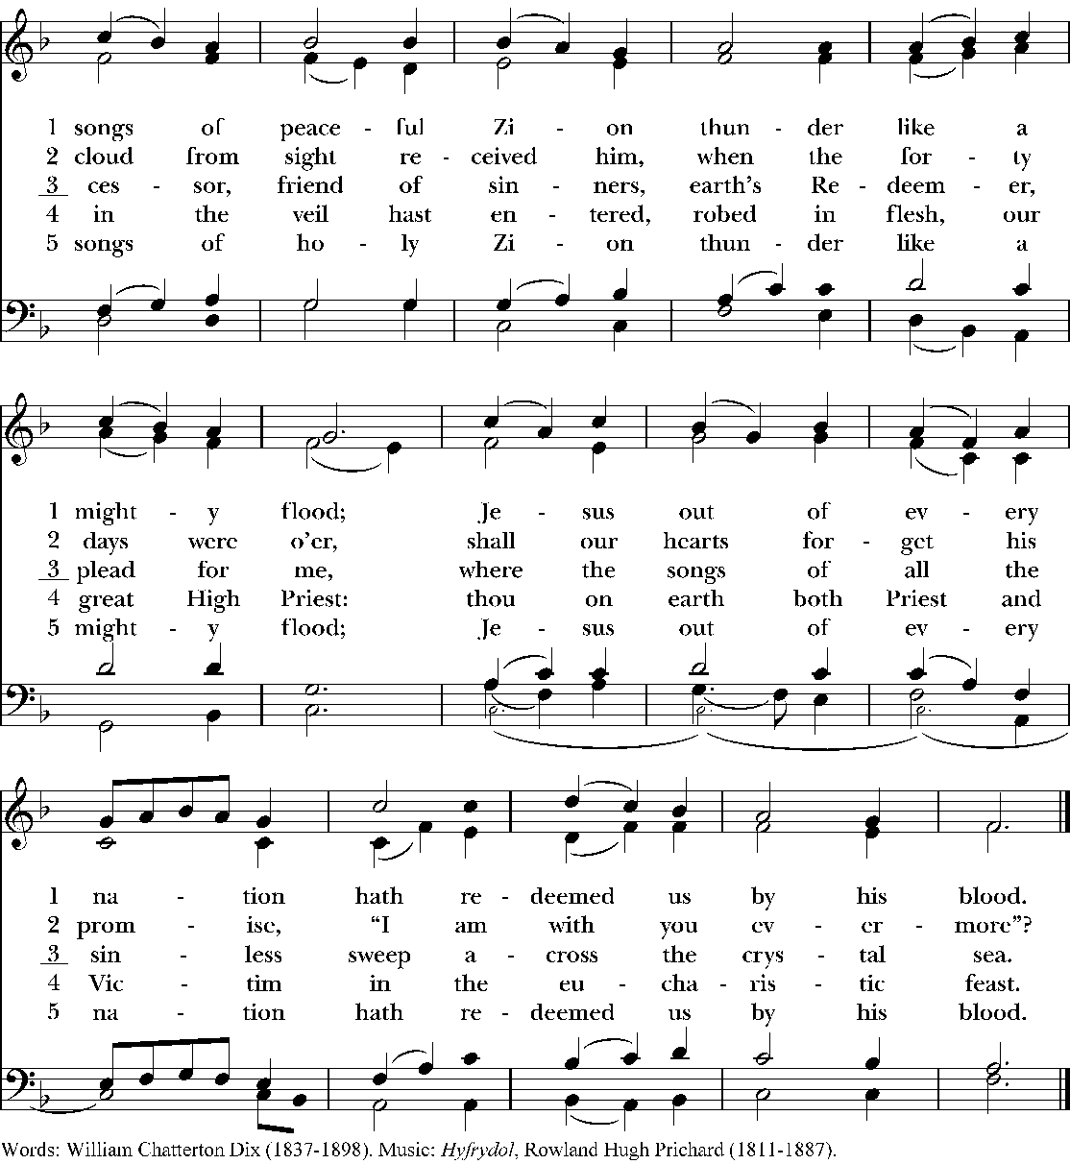

THE SENDING
Deacon Our worship is ended; our service in the world now begins. Go now in peace to love and serve the risen Christ. Alleluia! Alleluia!
People Thanks be to God.

POSTLUDE Paean, A Song of Triumph (Fanfare) Oliphant Chuckerbutty

If you would like to donate to support the Cathedral’s mission & ministries, please use the QR Code below



Liturgical Ministers | Music Ministers
Presider/Preacher: The Very Rev. Kathie Adams-Shepherd  Fifteenth Dean of Christ Church Cathedral  Verger: Alicia Pierce  Crucifer: Alan Young  Eucharistic Ministers: Br. Sam Kincade, osf; Urlene Branch  Eucharistic Visitor: Titus O Olajide  Lector: Urlene Branch  Intercessor: Robert England  Ushers: Claudine Allen, Alice Stanley  Altar Guild: Titus Olajide  Digital Moderator(s): Diane Chalberg, Mary Hovland  Coffee Hour Hosts: Coffee Hour Ministry | Organist and Choir Director: Dr. Connor Scott  Musicians: The Cathedral Choir  Cathedral Choir Soloists & Section Leaders  Riley Cameron, baritone  Sarah Campbell, alto  AJ Murgo, tenor  Lea Zelaya, soprano  Cathedral Choir Scholar Singers  Mackenna Glazer, soprano  Daniel Pollien, tenor  Lauren Waight, soprano

Copyright Notices
All music, words, and graphics reprinted with permission under One License #A704939, CCLI/ASCAP License #15815, and RiteSong #CPIRS29265 agreements, all rights reserved. All usage reported to respective licensing organizations.
St. Columba by Healy Willan, © 1956, Peter’s Editions.
Canticle 20, Glory to God: Gloria in excelsis, #280 from The Hymnal 1982, Service Music — Music: Robert Powell (b. 1932), rev. Setting: Copyright © Church Publishing Inc. H#204 Now the green blade riseth, Noël nouvelet, Words: From The Oxford Book of Carols, © 1964, Oxford University Press., Music: © Alphonse Leduc. Adapt. © Roy F. Kehl. Acc. © George Mims.
Psalm 66:7-18, based on Moscow, Hymnal 1982 #537, Chant from A HymnTune Psalter, Revised Common Lectionary Edition © 2007 by Carl P. Daw, Jr. and Kevin R. Hackett. Church Publishing Incorporated. Pointing by C. Scott, translation from the Inclusive Psalter from the Anglican Church of Canada, General Synod 2016 edition.
You Cannot Lose My Love, Sarah Groves, arr. Sarah Labarr © 2002, and 2013 Santa Barbara Music Publishing, Inc.
Doxology. Words: Rev. J. Mary Luti © 2024, used with permission. Music by Ralph Vaughan Williams, public domain. Graphic by Connor Scott © 2024.
Sanctus from A Community Mass by Richard Proulx © 1977 GIA Publications, Inc. Inclusive and expansive text revisions and graphics by C. Scott.

Christ Church Cathedral
The Episcopal Cathedral of the Diocese of Missouri
Dean  The Very Rev. Kathie Adams-Shepherd  (314) 255-1640  kas@christchurchcathedral.us  Director of Music: Organist &  Choir Director  Dr. Connor Scott  (636) 524-9876  cscott@christchurchcathedral.us  Associated Priest  The Rev. Jeff Goldone  jgoldone@christchurchcathedral.us  Deacon  The Rev. Dcn. Justin Martin  justin.g.martin.12@gmail.com  Cathedral Social Worker  The Rev. Carol Wesley, PhD  cwesley@christchurchcathedral.us | Bishop of Missouri  The Rt. Rev. Deon K. Johnson  Eleventh Bishop of Missouri  Lead Missioner  Thomas Adams  tadams@christchurchcathedral.us  Missioner for Formation & Serving Neighbors  LaTonya Logan  llogan@christchurchcathedral.us  Director of Operations  Pamela Reitmeyer  (314) 255-1641  preitmeyer@christchurchcathedral.us  Cathedral Administration Consultant  Annette Carr  (314) 255-1664  acarr@christchurchcathedral.us  Cathedral Bulletin Writer  Carol Westpfahl  bulletins@christchurchcathedral.us | Chapter Senior Warden  Carol Fletcher  watsonsmount@aol.com  Chapter Junior Warden  Mike Rohan  mer01@sbcglobal.net  Chapter Treasurer  Ron Freiwald  wierfr@gmail.com  Chapter Assistant Treasurer  Kris Reppert  kreppert@charter.net  CCC Convocation/Convention Delegates  Mary Randlett, Urlene Branch, Alice Stanley,  Jane Mayfield, Kurt Joice  Security Guards  Gateway Security, LLC  Cathedral Cleaning Company  Stratus Building Solutions
Cathedral Contact Information
1210 Locust Street,
St. Louis, MO 63103
Phone (314) 231-3454
www.christchurchcathedral.us

